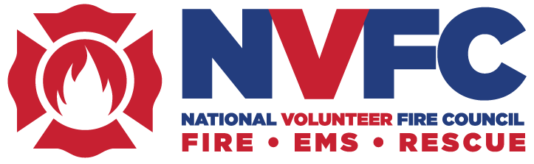

Social Media Posts for December 2018

Please follow us on Twitter @nvfc and on Facebook @nvfc1 to directly share any content you feel would be useful for your members. You can also use these handles to tag the NVFC in the following posts or in any posts from your organization that you’d like us to share.

Animated Videos suggested posts

Leadership:

Listening is leading, too. Promote open communication in your department and be there for your members when they need you: http://bit.ly/2PiPrWw

Being a good leader means being there for your members. http://bit.ly/2PiPrWw

Teamwork:

Teamwork is part of the job. Work with your crew to prevent injuries and get the job done. http://bit.ly/2zINNbU

First Responder Incentive Program suggested posts (to use with attached image)

FCA is offering exclusive incentives for firefighters and emergency responders on eligible vehicles, including the Ram 1500. Learn more here: http://bit.ly/2E64At9

Need a new car or truck? FCA offers exclusive incentives for firefighters and emergency responders on eligible vehicles! http://bit.ly/2E64At9

Fire/EMS Helpline suggested posts

The holidays can be stressful, especially for volunteer emergency responders. If you need help, reach out. The Fire/EMS Helpline is free, confidential, and available 24/7 at 1-888-731-FIRE (3473). www.nvfc.org/help

Firefighters, EMS providers, and their families can call the Fire/EMS Helpline any time for assistance with any behavioral health issue. It’s free and confidential. 1-888-731-FIRE (3473), www.nvfc.org/help

If you see a fellow firefighter or EMS provider struggling, reach out. Here are some tips to talking to a responder in need: https://youtu.be/SlYXV4Ww2iE. The Fire/EMS Helpline is also available 24/7 at 1-888-731-FIRE (3473).

Holiday Giving suggested posts

Looking for a holiday gift for a firefighter or EMS provider? Give the gift of NVFC membership! Benefits last all year and include the Volunteer Voices member forum, free Virtual Classroom training, an AD&D policy, personalized membership card, and more. www.nvfc.org/BeYourBest

Shop the NVFC store this holiday season to find gifts for the first responders on your list: https://nvfc.force.com/CPBase__store

You can support the NVFC with your holiday shopping! Use this link from AmazonSmile and Amazon will donate to the NVFC: https://smile.amazon.com/ch/39-1274172

Did you know that 70% of firefighters are volunteers? Make sure these heroes have the tools and resources they need to protect and serve your community. Donate to the National Volunteer Fire Council here: http://ow.ly/mjLq30mDrWJ

Your contribution makes a difference! Help the National Volunteer Fire Council provide needed resources, training, and programs to volunteer firefighters, EMS providers, and rescue workers. Donate here: http://ow.ly/mjLq30mDrWJ

